RTOS Master Class by SPRINTS Egypt (Udacity)
Implementation of an EDF Schedular Based on FreeRTOS

By : Michael Samir
Msmb.mail@gmail.com

ID | Task | Periodicity (ticks) | Execution Time (ms) | Calls in Hyper Period
1 | Button_1_Monitor | 50 | 0.019 | 2
2 | Button_2_Monitor | 50 | 0.0193 | 2
3 | Periodic Transmitter | 100 | 0.02465 | 1
4 | Uart_Receive | 20 | 0.02352 | 5
5 | Load_1_Simulation | 10 | 5 | 10
6 | Load_2_Simulation | 100 | 12 | 1

Hyper Period = LCM(Periodicities) = LCM(50,50,100,20,10,100).
HyperPeriod = 100

CPU Load = ( Total Time / HyperPeriod ) * 100

Total time = (0.019*2) + (0.0193 * 2) + (0.02465 * 1) + (0.02352*5) + (5*10) + (12*1) = 62.21
CPU Load = 62.21 %

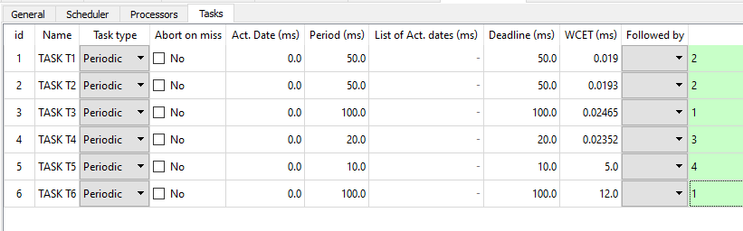

Since D=10 ms and W(10) = 5 ms so Task # 5 : is schedulable.
For Task 4 :
W(20) = 0.02352 + (20/10) * 5 = 10.02352 ms
Since D = 20 ms and W(20) = 10.02352 ms
W(20) < D so Task 4 is schedulable.
Make the same for other taskes we got that :
Task #1 , 2 , 3 ,6 are schedulable.
Therefore, our system is schedulable.

